- How many hours did it take you to complete this assessment?
It took me around an hour to do problem1. An hour to figure out problem2. Problem3 took me around 1.5 to 2 hours. And problem4 took me around 45 minutes to an hour to implement the Scalable class and the override methods to scale the shapes.

- What online resources did you use?
I used StackOverflow, GeeksforGeeks, w3Schools, Gemini AI.

- Did you get help from any classmates?
No I didn’t get any help from class mates.

- Did you ask for help from an instructor?
No I didn’t ask any questions to any instructors.

- Rate the difficulty of each problem and your confidence in solving similar problems in the future.
Problem1 – 3/10
Problem2 – 4/10
Problem3 – 5/10
Problem4 – 6/10
I feel much more confident I can solve problem like this in the future.

Screenshots of outputs on the next pages.

Problem1
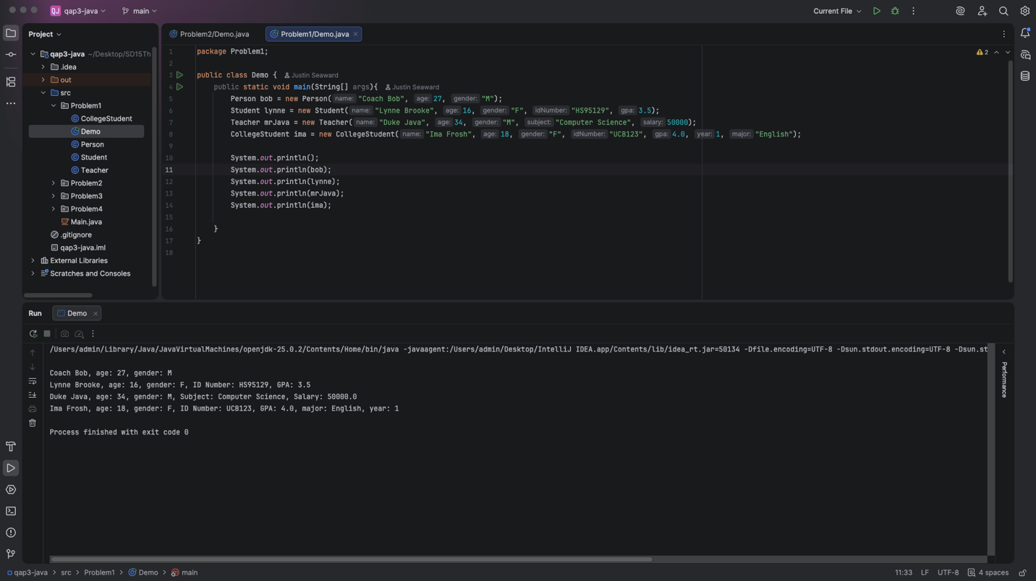

Problem2
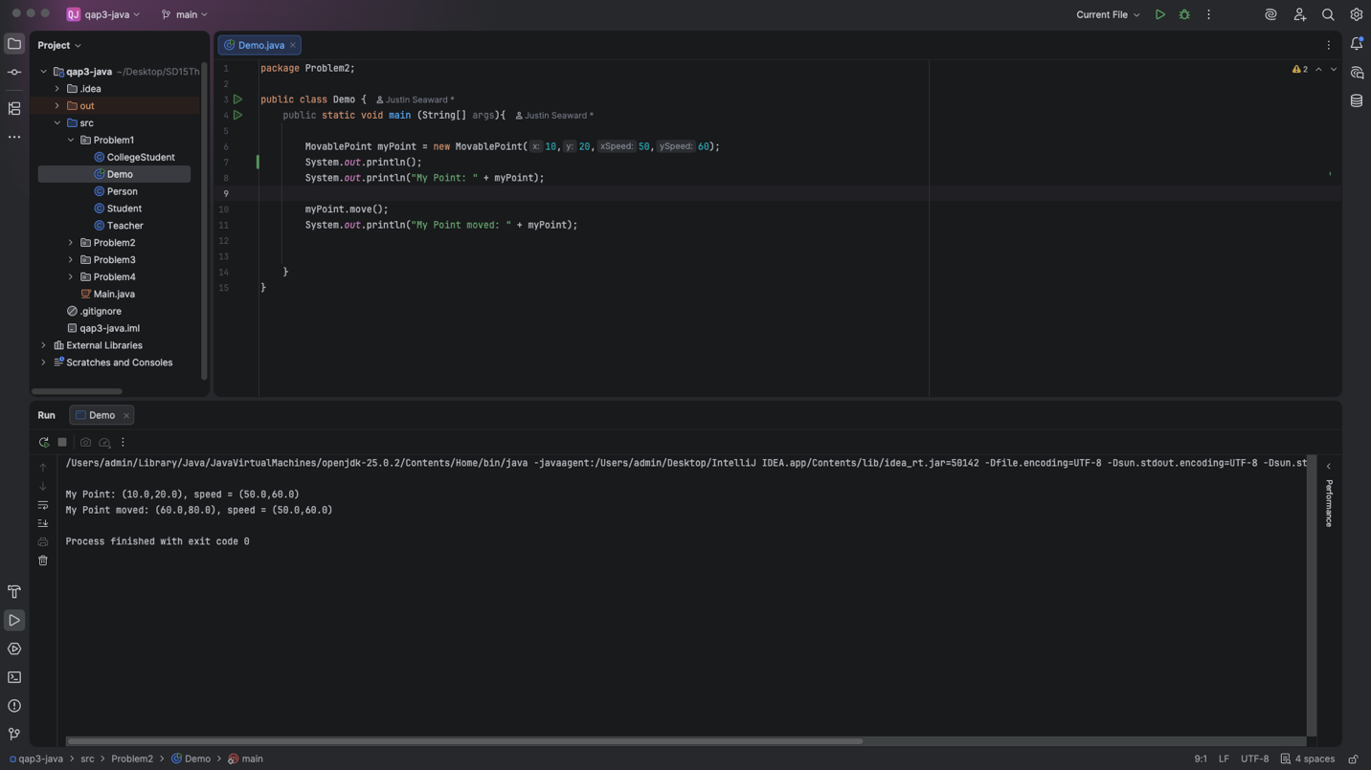

Problem3
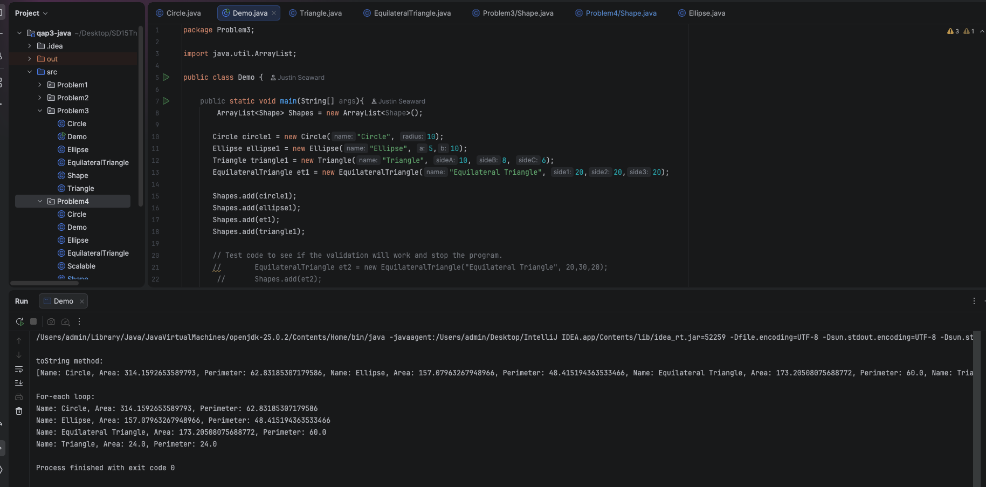

Problem4
